Case Study — Pachora Expansion Opportunity

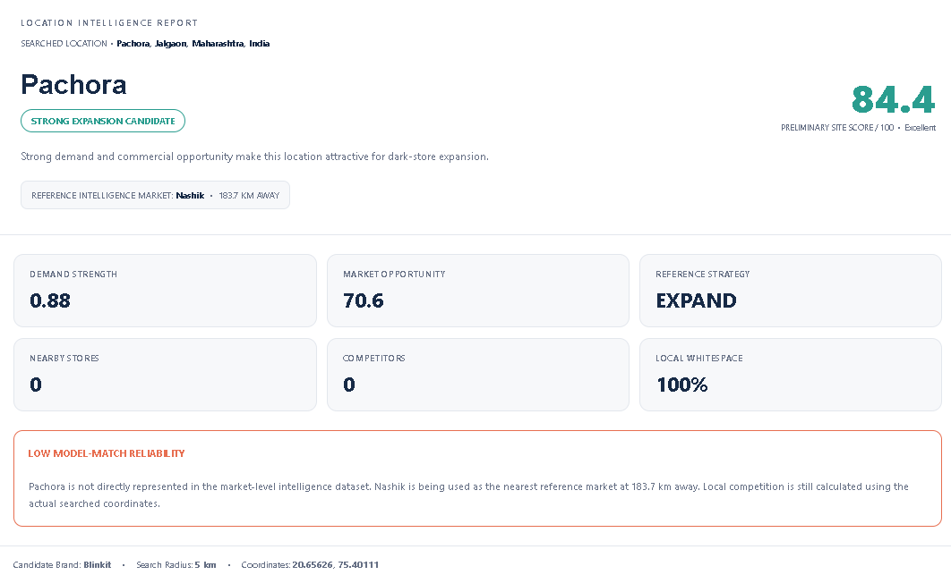
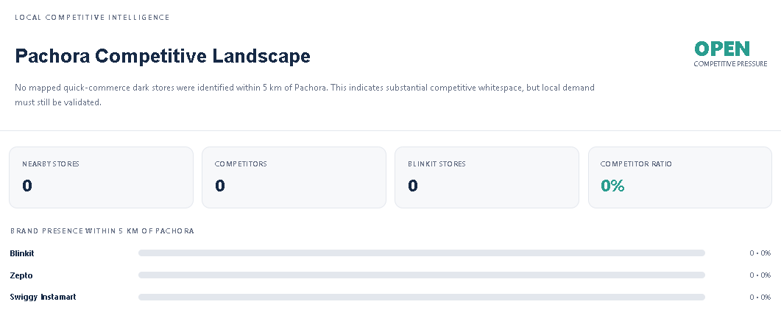
The model evaluated Pachora, Maharashtra for Blinkit and generated a site score of 84.4/100, classifying it as a Strong Expansion Candidate.
With 0 nearby competitors and 100% competitive whitespace, Pachora shows strong first-mover potential. However, since the demand estimate uses Nashik (183.7 km away) as the reference market, the result has low model-match reliability.
Outcome: 🟢 High Potential — Shortlist for local feasibility validation.

Case Study — Mumbai: High Demand, High Competition

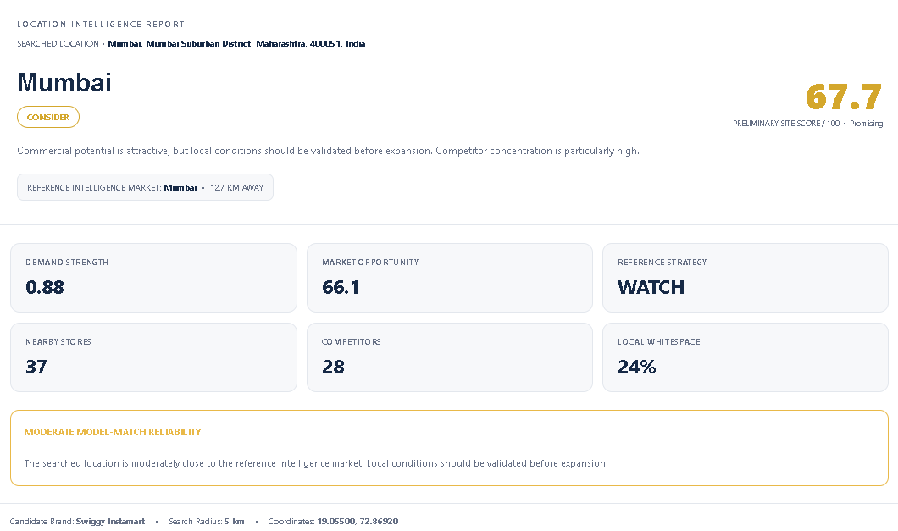
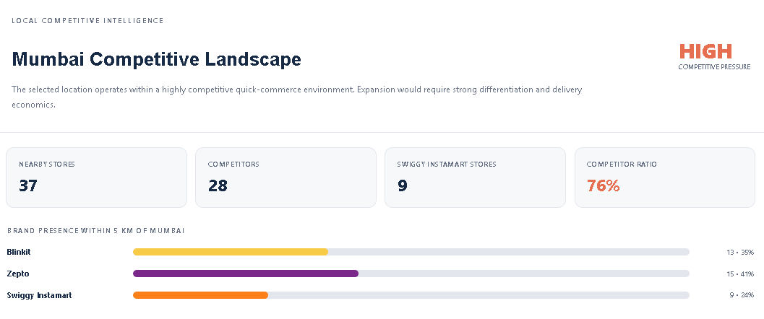
The model evaluated Mumbai for Swiggy Instamart and generated a site score of 67.7/100, classifying it as CONSIDER / WATCH.
Despite strong 0.88 demand strength, the 5 km radius contains 37 dark stores, including 28 competitors, resulting in a 76% competitor ratio and only 24% local whitespace.
Outcome: 🟡 Promising Market, but high competition makes expansion riskier — validate carefully before expansion.

